Assessment Cover Sheet

Unit Code and Title | ICT930 Advanced Web Application Development
Assessment Name and Number | Assessment 2 Frontend Design Overview
Teaching Period / Year | Semester 2/ 2026
Lecturer / Unit Coordinator | Dr Arman Sharififar
Group Member | Aadarsha Neupane CIHE260281 SkillTrack
Submission Date | 06/09/2026
Submission Type | Individual Group

Team Members (Complete ONLY for group assessments)
Student Name | Student ID | Contribution (%) | Responsibilities for the Assessment
AADARSHA NEUPANE | CIHE260281 | 100% | Entire Project

Declaration
By submitting this assessment, I/we confirm that this work is my/our own and complies with the CIHE Academic Integrity Policy and the QA70 Use of GenAI in Teaching, Learning, Assessment and Research Policy. Any use of AI or other tools has followed the assessment instructions and guidance provided in the CIHE Student Guide on the Use of AI and has been fully acknowledged in the AI/Tool Use Declaration Table below. I/we understand that inappropriate or unacknowledged use of AI, or submission of work that is not my/our own, may constitute academic misconduct. I/we also confirm that this assessment has not been previously submitted unless approved, and I/we consent to its use for standard academic integrity, quality assurance, and AI governance review processes.
Student(s) Signature:
Date:
GenAI Tool | Description
ChatGPT, Claude | Used to summarise and interpret the project brief, brainstorm project ideas, clarify technical concepts, suggest report structure, improve grammar and sentence clarity, troubleshoot coding problems, provide guidance on GitHub version control and deployment issues, review code structure, and debugging.

Table of Contents
1. Introduction 3
2. Application Overview 3
3. Architectural and Technical Choices 4
4. UI/UX, Accessibility and Responsive Design 5
5. Challenges and Solutions 5
6. Industry Relevance and Deployment 6
7. Individual Reflection 6
8. Team Contribution Statement 7
9. Conclusion 8
References 9

Introduction
SkillTrack is a responsive education and training system created as a frontend application based on React technology. The primary goal of the platform is to give students a chance to explore courses, enroll in learning material, track progress, create career roadmap, take knowledge tests and achieve goals. It was chosen as a problem domain as learners in today’s world require not only a list of available courses but also progress tracking, learning paths and motivation for continuing.
The primary aim of the project was to design and implement a fully-functional frontend that will display important aspects of advanced web development and remain consistent and accessible at the same time. The application was implemented using React, Vite, React Router, JavaScript, CSS, Context API and mock JSON data. It wasn’t just about creating visually appealing web pages; I wanted to show how components, routing, state management, data fetching, forms and validation could be used in a single frontend application.
It being a single developer project, I had to take care of planning, design, implementation, testing and documentation of the application.

Application Overview
SkillTrack offers several interconnected views that describe various steps along the way in the learning process. The application is comprised of a number of interrelated views, such as the Home page, Course Catalogue, Course Details, Dashboard, Roadmap, Achievements, Quiz, and Profile. All these views are responsible for performing a certain purpose in the learning platform. Navigation from client side was done using the react-router component, thus the user could navigate through views without reloading the page.
The course catalogue is one of the important features of this applicatio. Users can browse for the needed course and use filters to filter the results. The selection of a particular course provides additional details and gives the opportunity to enrol into it. After enrolling, the progress of each lesson can be checked from the course page. It will also be displayed in the dashboard.
The dashboard shows the activity of the learner, listing all the enrolled courses, completed lessons, and general progress. Additionally, I created an activity visualisation for the past week and learning streak lasting seven days to make the dashboard more interesting. Career roadmap presents a structured path for learning frontend development, whereas the achievement system awards users with badges for their learning activity.
Other characteristics include the frontend knowledge quiz where the learner can assess their knowledge on frontend topics and get a grade at the end of the quiz. Another page is the certificate page where the learner gets an outcome oriented result upon completing the course. The profile page helps the user to manage his/her basic information and career objectives.
These characteristics were introduced with the idea of creating a bigger ecosystem of learning in SkillTrack rather than just listing courses.

Architectural and Technical Choices
React was chosen because of its component-based architecture which suited the application with many recurring interface items and several interactive views. The component-based approach of React makes it possible to divide the interface into smaller, reusable components and not having all functionalities in one page. This helped in organizing and improving maintainability of SkillTrack.
Vite was the build and development tool used in the project. Vite offered a light development environment and an easy production build procedure. Project Structure is made up of pages, reusable UI components, shared context, services, dummy data, and styles. The components folder holds reusable UI components such as Navbar, Footer, CourseCard, ProgressBar, Modal, Loading, ErrorMessage, and Button. This approach ensures that only specific parts of the application will be affected by changes in particular elements.
React Router was used in this project to manage routing on the client-side. The routes available in the app are home, courses, course detail, dashboard, roadmap, achievements, quiz, certificate, and profile. Dynamic routing was also included for course details view.
For state management, local state with React hooks and shared state with Context API were employed. Local state should be used when interaction belongs to a particular component, like search value or form interaction. The shared state is needed for user, enrolled courses and theme, which are necessary for more than one page. Hence, all these values and functions were moved to AppContext.
Course progress is an example of that. Whenever a user enrols in the course, the app creates an enrolled course state, including completed lessons and progress in percentage. Whenever lesson is selected, the completeLesson function adds it to the completed lesson list and calculates percentage based on the number of completed lessons. As a result, the progress shown on course pages contributes to the progress shown on dashboard.
I also separated getting course data into a service layer. Since there are no backend services in my project, I use courses.json file as mock data and courseService.js file for getting all courses and a particular course. I included a small asynchronous delay in order to mimic the process of getting data from an external source. It helped me include loading and error states.
The above mentioned application has thus shown how it works on an architecture where the pages deal with larger feature spaces, reusable components deal with repetitive UI, Context deals with the shared state, services deal with data fetching, and JSON acts as the fake data source. This kind of structure was very important for maintainability purposes.

UI/UX, Accessibility and Responsive Design
While creating the design, I made an effort to create visual consistency in all of SkillTrack. There are consistent patterns used for such elements as cards, buttons, form fields, headings, spacing and navigation. This approach helps not to teach the user a new interface every time he or she moves from one page to another. The hierarchy is done by the means of larger headings, smaller text and eyebrow labels.
Navigation has been an important part of the process because the application includes many views. I created a reusable navigation component with the links to all the important areas in the application. Also, navigation includes responsive mobile menu and light/dark theme switcher. Logo has been placed in the navigation to enhance the SkillTrack brand.
The responsive design has been developed using CSS media queries. Multi-column layout can be used on large screens for courses cards and dashboards while on small screens they can be rearranged into single-column layouts. Mobile navigation turns into menu button and this way the screen space can be used better.
Accessibility has been taken into account during design. Semantic HTML tags have been used where required, form fields have appropriate labels, navigation includes an accessible label, and interactive controls contain appropriate accessible name. Focus styles have been included in form inputs, and there is also reduced motion support within the application for users with preferences enabled for prefers-reduced-motion.
The application also has user feedback through loading indicators, error messages, progress bar, validation messages, and completion information. Such kinds of feedbacks allow one to get an idea about what’s happening rather than leaving the user confused.

Challenges and Solutions
The main problem that I had to face was working with an increasing application state. While initially each page had its own state, later features like enrolment and progress required sharing data across different views. To deal with that I implemented the Context API and put all shared learner and course information in AppContext.
Another difficulty was to make the data seem more like actual data source, since loading JSON right away would make an illusion of instant availability of information. That is why I implemented courseService.js where asynchronous functions with some delay were used. That way the interface could show loading state and also cope with missing course information.
It was also necessary to implement search and filtering, which were supposed to show only the courses the user wanted to see. For that reason, I made the search bar and filter panel separate reusable components, allowing the courses page to coordinate their filtering actions.
The issue of responsive design was another one. A design that is good for a regular computer screen may be overcrowded on a mobile device, especially with a number of navigation links, filters, and dashboard cards. In order to solve this problem, I made use of CSS breakpoints, flexible grids, and mobile navigation menu. The layouts were checked at various viewport sizes and were adjusted to fit them.
Moreover, there appeared a problem of preserving consistency while adding new features to the interface. Such features as achievements, roadmap, quiz and certificate could easily look like mini-applications on their own. Making use of the same components (cards, buttons, headings, spacing, progress) helped keep the design coherent.
Finally, as the project was done solo, there was the need to take care of the development process on my own. By making use of Git and GitHub, it became possible to track real changes in the course of development. It was done by using development branch for my changes and making a pull request in order to include finished navigation into the main branch.

Industry Relevance and Deployment
The SkillTrack application employs some techniques which are typical for modern frontend web development. The use of component-based architecture, client-side routing, state sharing, asynchronous operations and responsive design is appropriate for professional projects. The separation of the service layer from presentation is also a good basis for further replacement of the mock JSON dataset with real backend API in the next version.
It is also possible to speak about the relevance of maintainability as an aspect which was applied within the project. Instead of duplication of common parts on pages, the reusable components were developed for the following elements: navigation, buttons, progress, loading messages and courses' cards. It would facilitate future updates of those elements because it will be enough to update the shared component.
The usage of GitHub in the process of development was also crucial. It helped to have the version control and activity tracking of the development. Such approach in a professional environment allows code reviewing, issue tracking and collaboration.
Deployment is an essential last phase of the project. The SkillTrack app has been deployed through Vercel and can be accessed online via the following URL https://ict-930-skill-track.vercel.app/. After implementation, I tested the application separately from the local development environment to ensure the core functions were still available. This phase also provided a chance to check for any discrepancy between the development environment and production environment and confirmed that the app can be accessed via the public URL.

Individual Reflection
Working on SkillTrack as an individual project has expanded my knowledge of the frontend development workflow since I was responsible for going from planning, designing, implementing, debugging, to documenting. Unlike being focused on a particular feature, I had to get an understanding of how different parts of the app interacted together.
Apart from other useful things that I have learned, state management has been one of the most significant lessons in frontend development. Not only it consists of making visually appealing screens but also involves features like course progress where appropriate state management is needed and search and filter features which require predictability in data processing. Both responsive design and accessibility require implementation and cannot be just added on at the last minute.
Another aspect of coding that I learned was proper use of React's component-based architecture and the differences between local and shared state. Working with Context API taught me when shared application state should not be passed through multiple layers of components and how creating reusable components helps keep separation of concerns.
Moreover, it was a great exercise for debugging and troubleshooting. When there were unexpected results from interaction, then it meant that I had to identify whether the problem existed in the component itself, state, routing, data, or styling. Through that, I learned how to approach a problem in an organized manner instead of just changing everything randomly.
Had I continued to develop SkillTrack, I would have implemented a real backend and a persistent database, allowing learners' information and their progress to survive page reloads and be related to specific user accounts. Moreover, I would have added new items to the roadmap, included better learning analytics and potentially an instructor/admin part in the further version. Nevertheless, those were additional elements that were not necessary for the current frontend assignment.
On the whole, the project allowed me to apply theoretical knowledge about the frontend in practice in a full-fledged application. I acquired a deeper understanding of React, routing, state management, responsive CSS and Git development.

Team Contribution Statement
Student: Aadarsha Neupane
Student ID: cihe260281
The SkillTrack assignment was completed individually. Despite being an assignment meant for three people as a team, I had the task of planning, designing, developing, testing, documenting, managing the GitHub repository, and deploying the application.
Some of my roles included designing the structure and UI of the application, coding the React components and pages, setting up the routing on the client side, state management, integration of the mock asynchronous data for courses, layout design, testing the functionality, GitHub repository management, documentation, and deployment using Vercel.
Contribution: 100% — all project work was completed by me.

Conclusion
SkillTrack efficiently combines all necessary frontend development ideas for the project implementation. The application contains a range of client-side views, reusable React components, state management on the global/local level, asynchronous handling of mock data, forms/validation, interactivity and responsiveness.
During the development, I realized how important it is to design an application as a system and not individual pages. The course enrollment influences progress, progress influences the dashboard, and activities help achieve accomplishments and provide learner’s experience.
It was tough working on the project individually; however, I gained useful practical experience within the entire frontend development lifecycle. The SkillTrack app is the evidence of my ability to plan, develop, test, and polish a modern React frontend.

References
React. (n.d.). React documentation. https://react.dev/
React Router. (n.d.). React Router documentation. https://reactrouter.com/
Vite. (n.d.). Vite documentation. https://vite.dev/
World Wide Web Consortium. (2023). Web Content Accessibility Guidelines (WCAG) 2.2. https://www.w3.org/TR/WCAG22/
GitHub. (n.d.). GitHub documentation. https://docs.github.com/

Appendix

Screenshots
Home Desktop
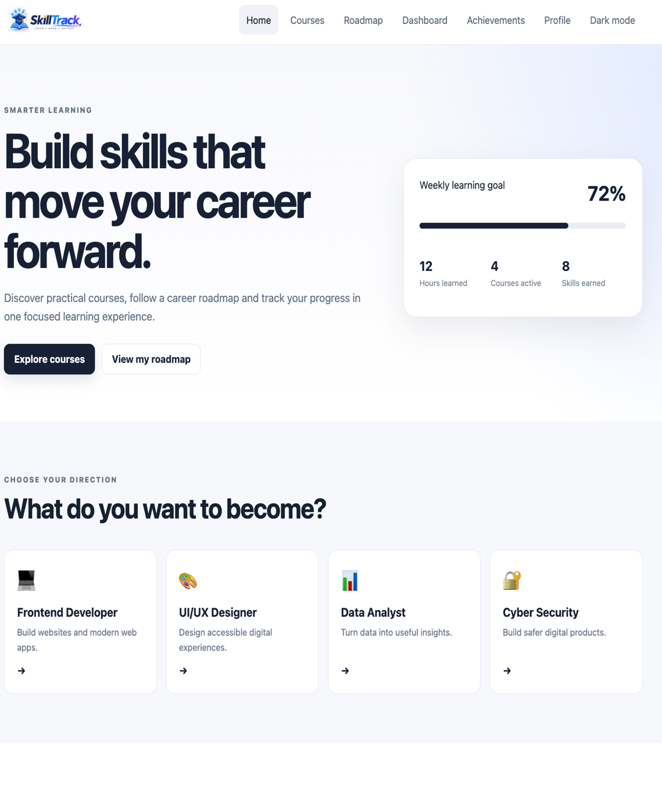
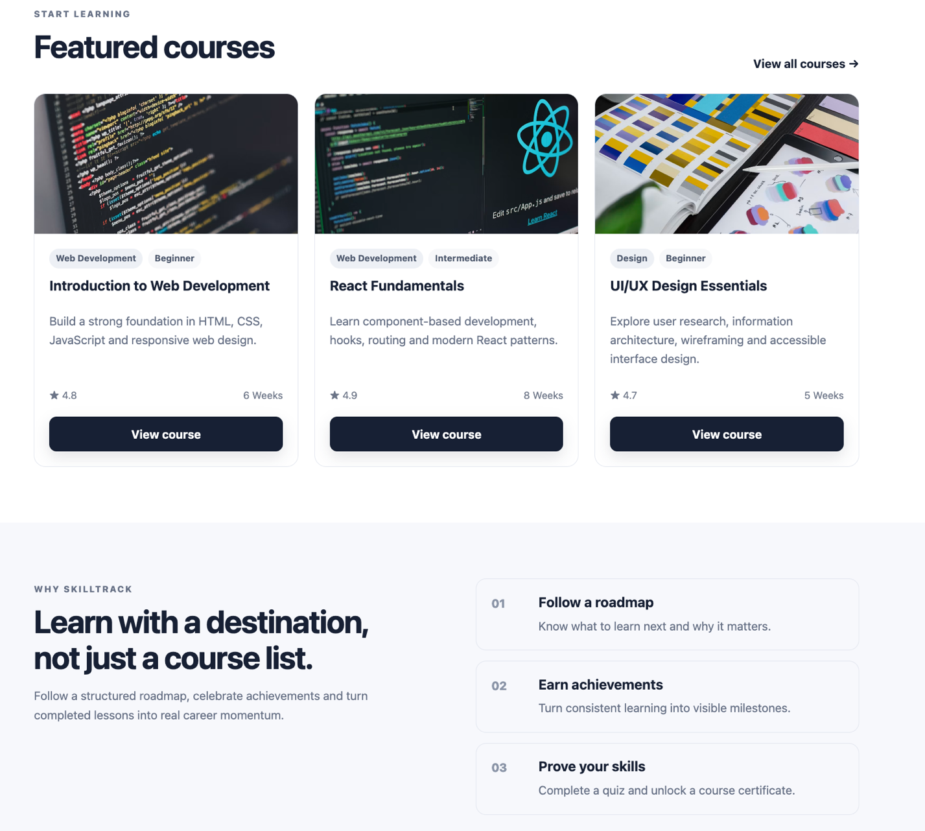

Home Mobile
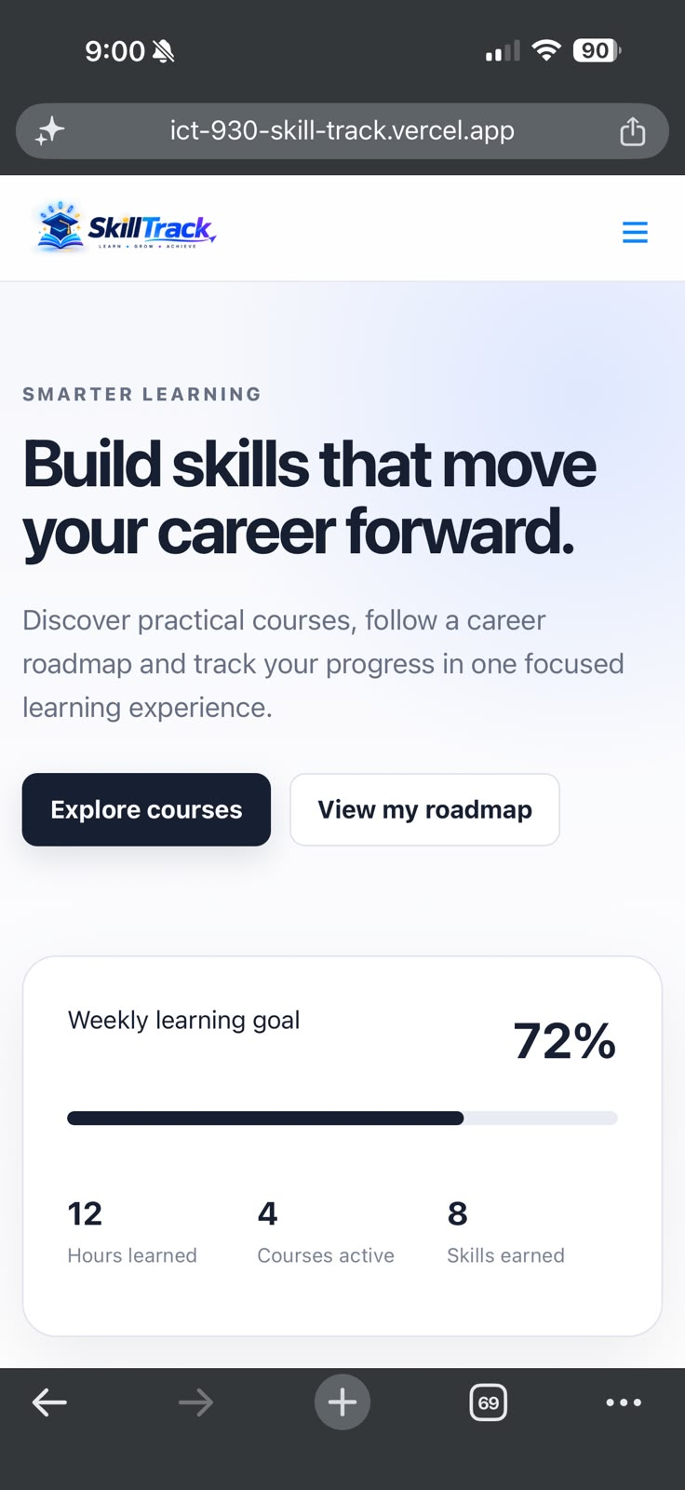
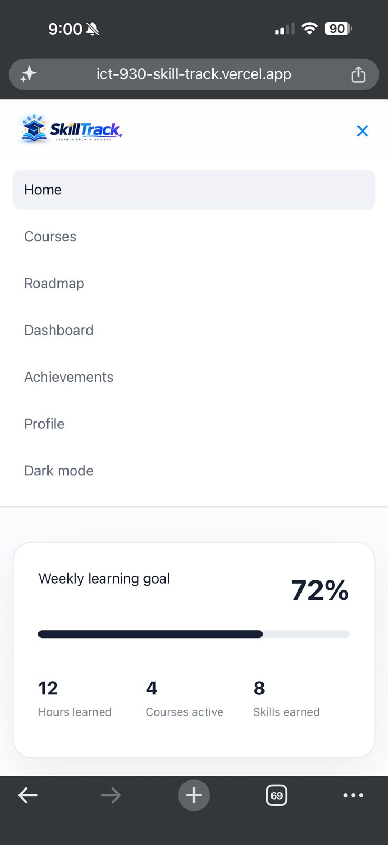

Courses Desktop
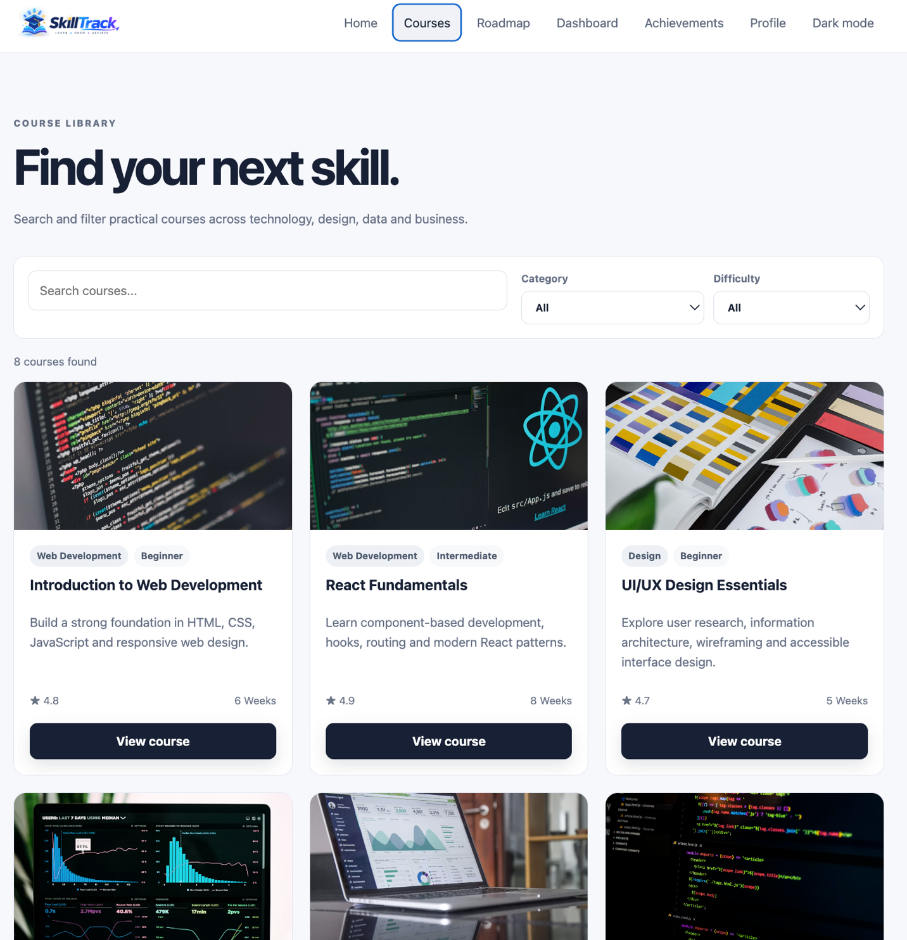

Courses Mobile
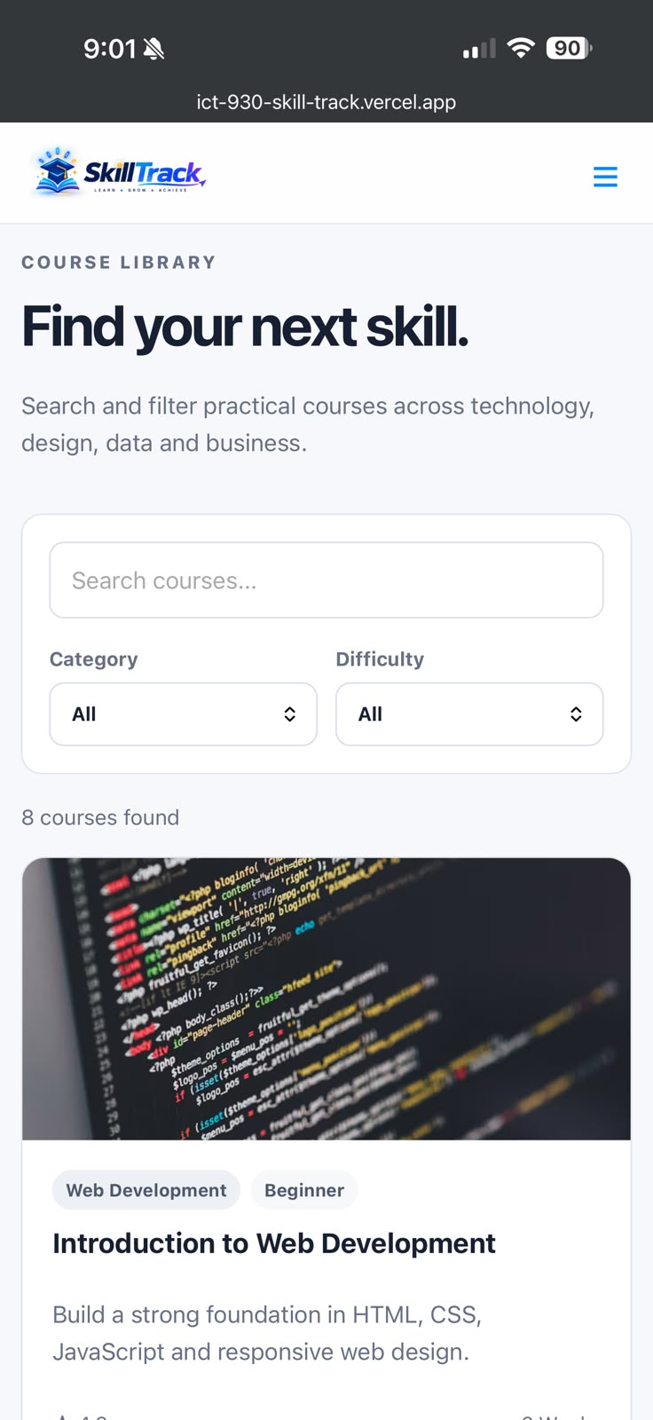
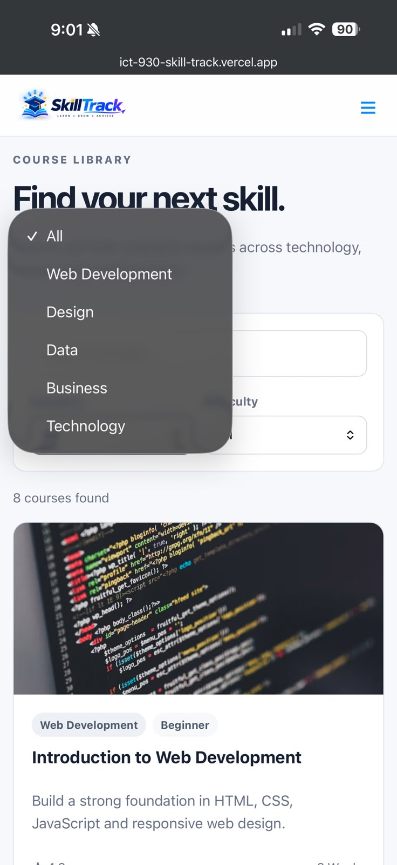

Course Details Desktop
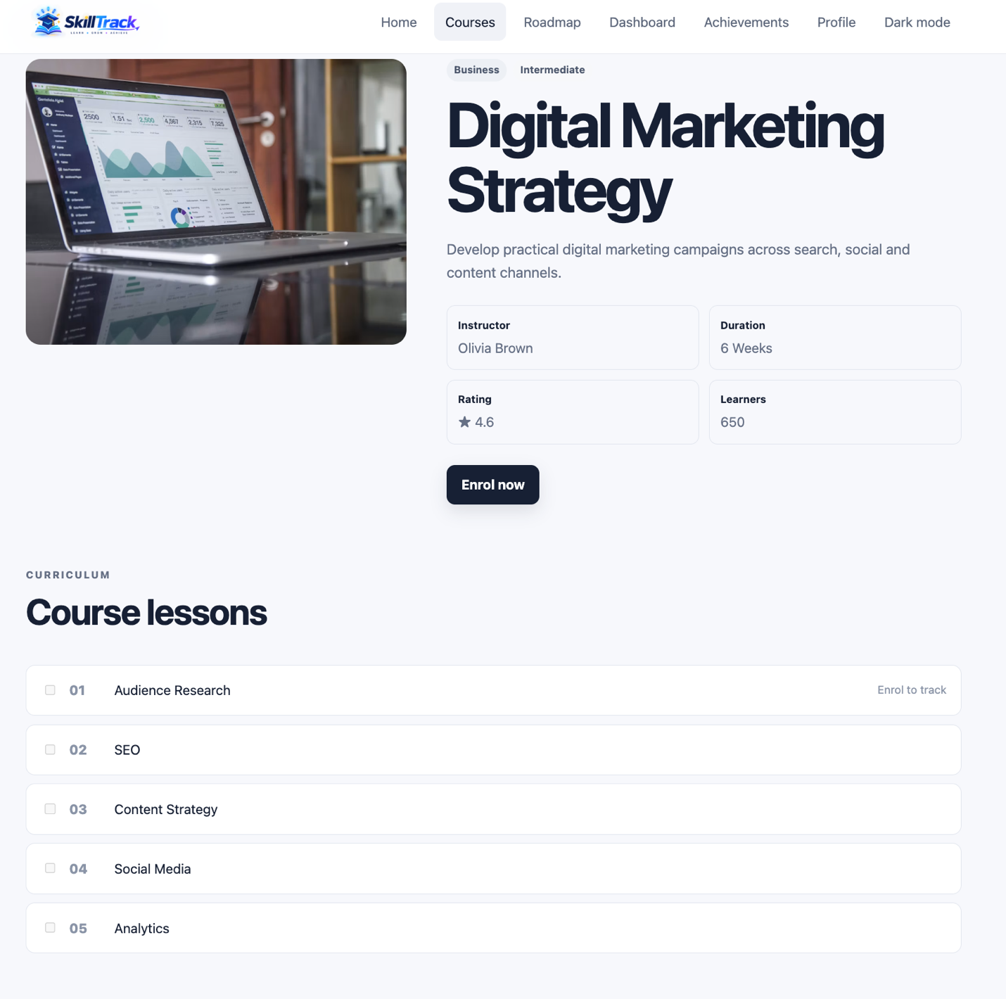

Course Details Mobile

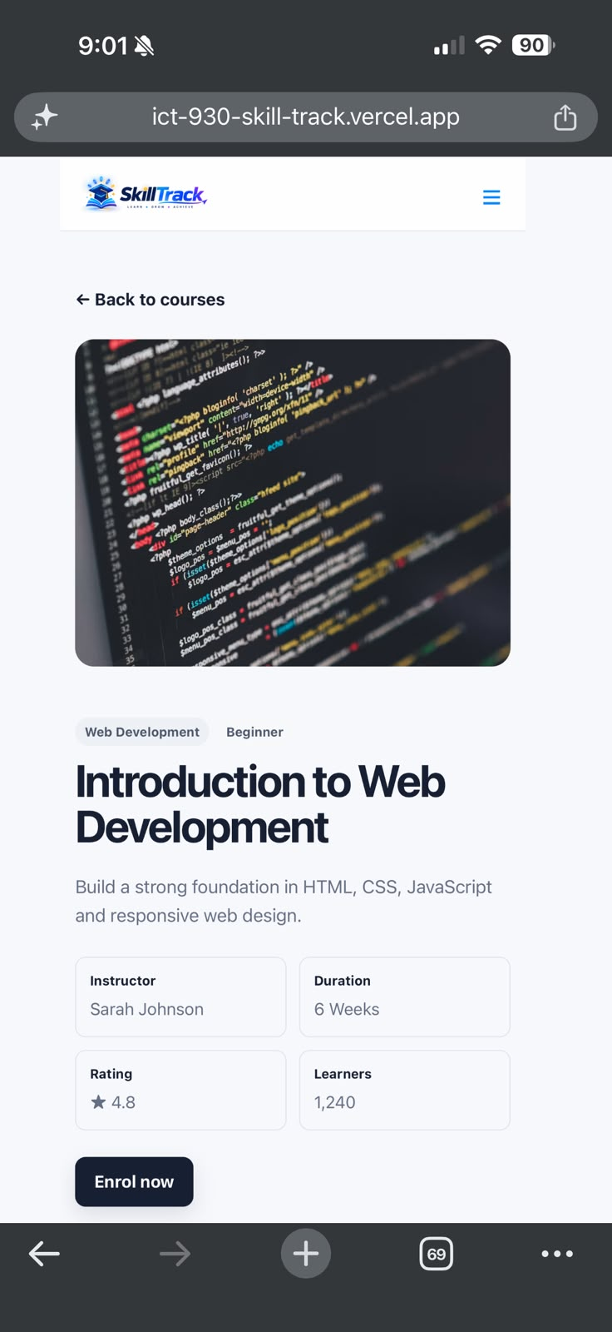

Dashboard Desktop
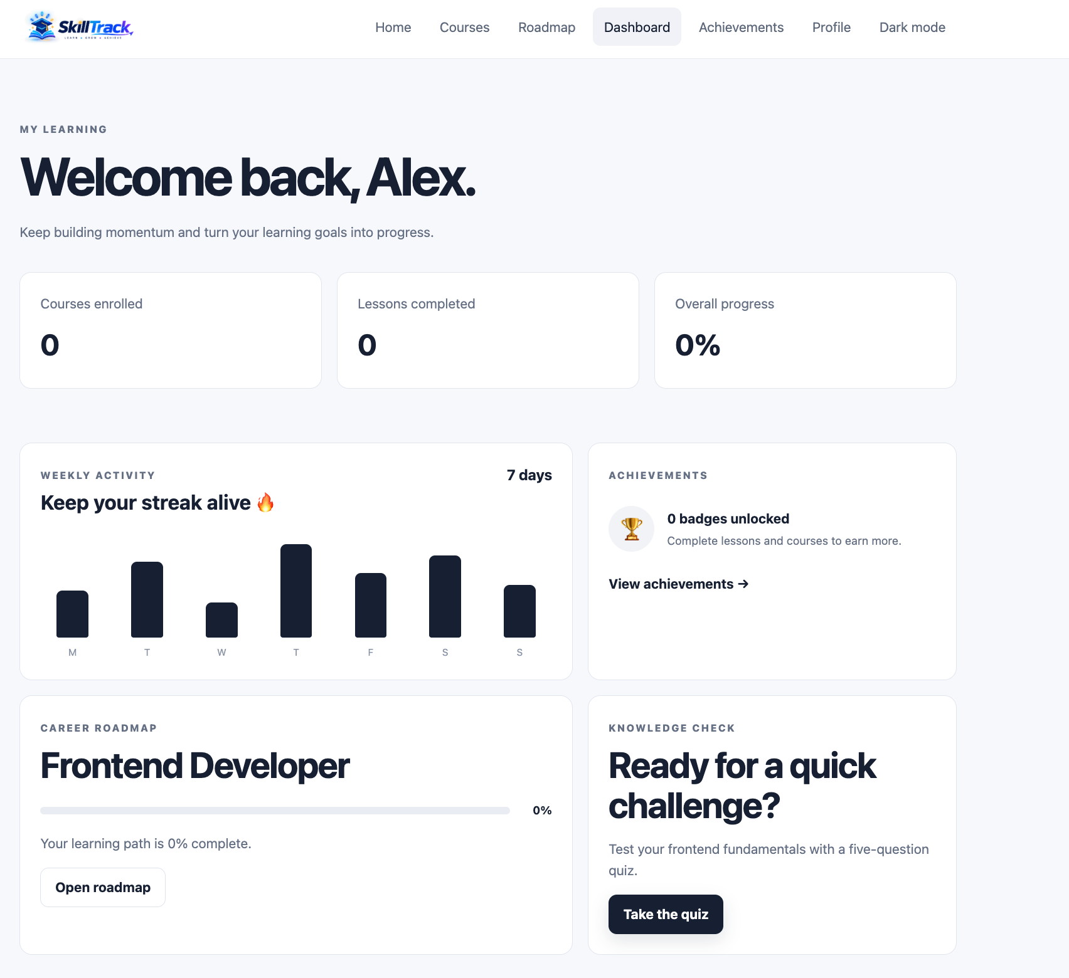

Dashboard Mobile
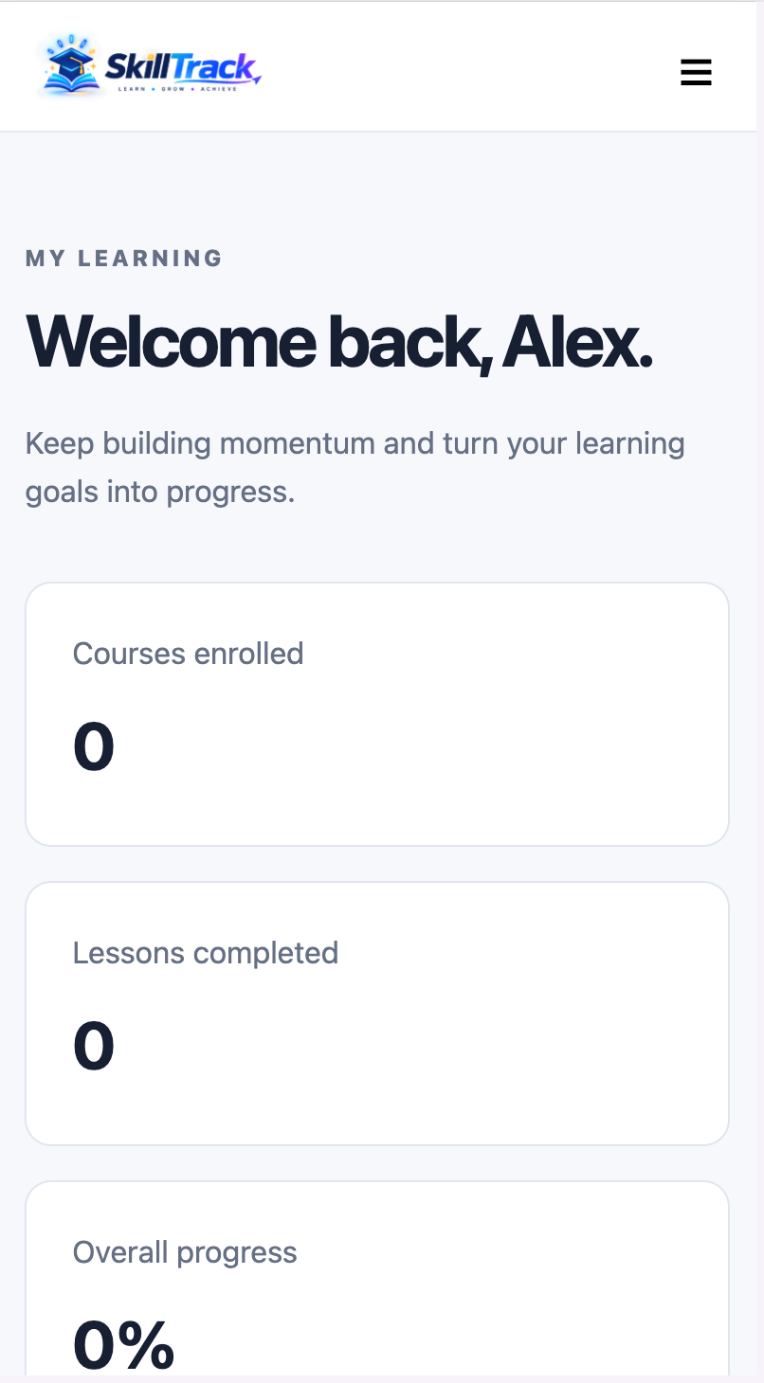

Roadmap Desktop
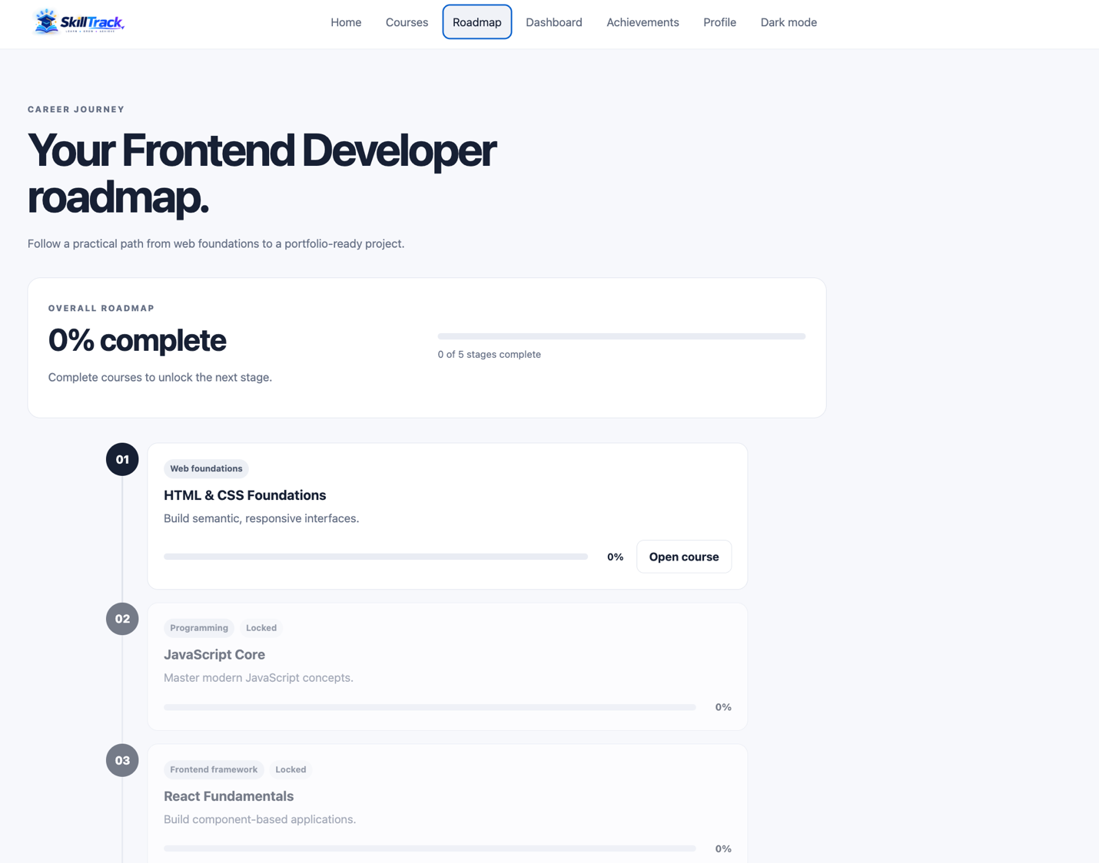

Roadmap Mobile
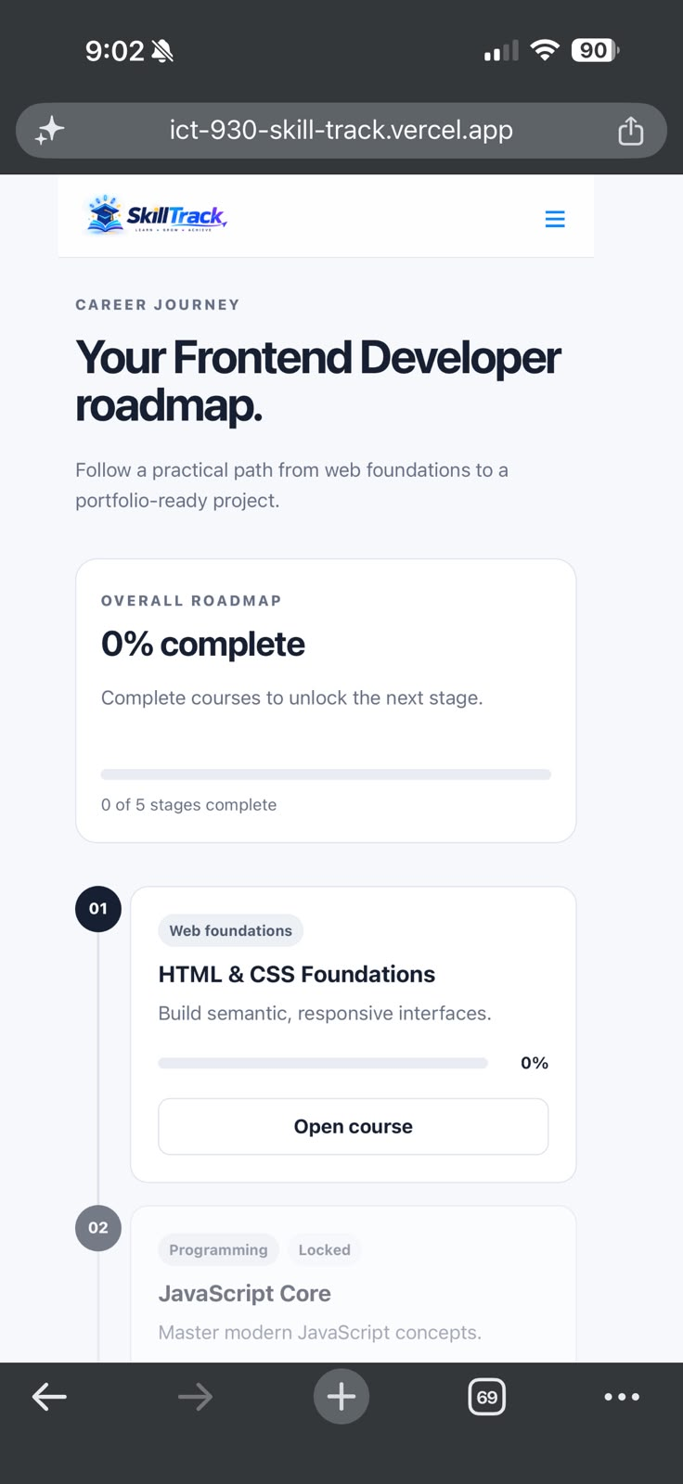

Achievements Desktop
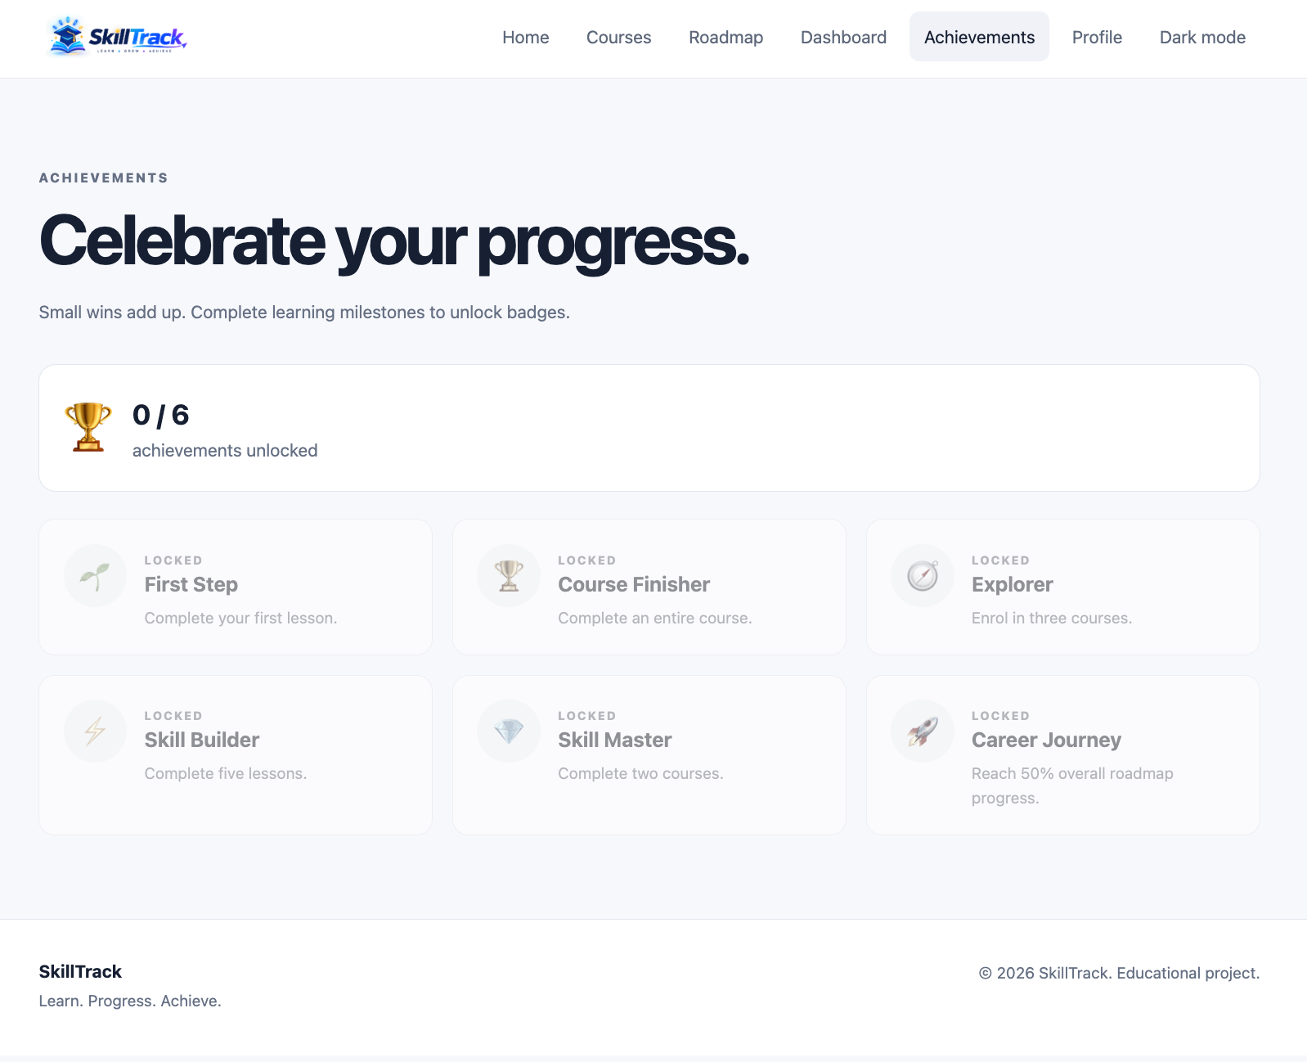

Achievements Mobile
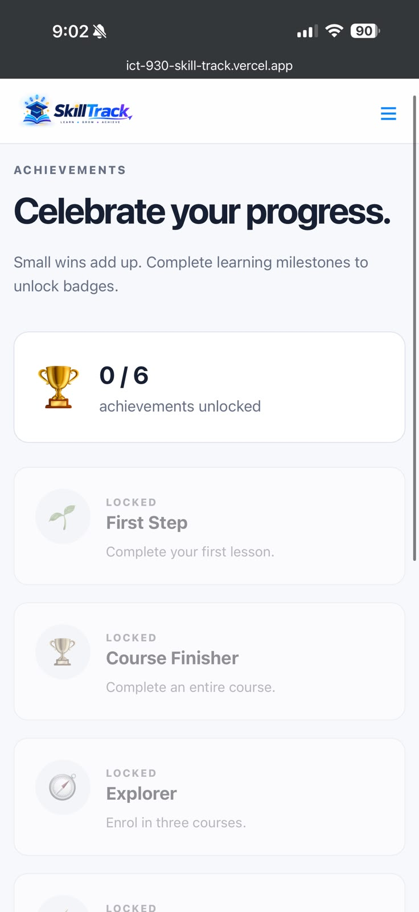

Dark Mode Mobile

